Search's Place in the Purchase Funnel
January 02, 2006
By Cam Balzer
Research and case studies show search's effectiveness in all three stages.
Many advertisers have moved beyond direct response and come to realize the branding value that search can deliver. Although still a young channel, analysis regularly uncovers new insights that help advertisers use search more effectively, and by examining search's place in the customer acquisition funnel, advertisers can find ways to get more from this profitable and still blossoming channel.
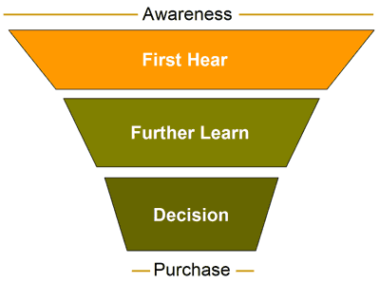
The customer acquisition funnel has been labeled differently over the years but most often begins with awareness and ends with a purchase decision. The top-down nature of the funnel suggests advertisers that create interest or pour awareness into the top of the funnel will reap the rewards as purchase decisions flow out the bottom. Although this model still holds true, search should not be pigeonholed in one or two stages. In fact, search is proving to be an effective tool in each stage of the funnel -- first hear, further learn and decision -- and research reveals many insights for advertisers seeking to accomplish more.
In July, for example, DoubleClick published its Touchpoints III research, in partnership with ROI Research. More than 2,100 U.S. adults aged 18 or older were asked about their purchases over the previous six months within 10 vertical categories. They were asked to attribute value to multiple marketing channels based on how much those information sources helped them at each stage of the process:
- Initial Awareness: How did you first learn about the product/service?
- Information Gathering: How did you further learn about the product/service?
- Purchase Decision: Which of the following most influenced your decision?
For each of these stages, the survey asked respondents to choose among 14 or more marketing and information factors (i.e., touchpoints). Nearly 20 percent of respondents said they turn to search to further learn about a product/service. Since search is synonymous with online research and has been since its inception; this should come as no surprise. Eyebrows begin to rise, though, when advertisers see search's potential in the other stages.
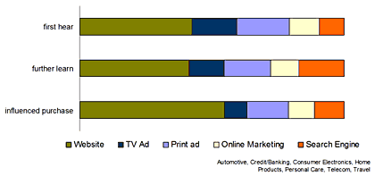
Eleven percent of respondents listed search as a valued touchpoint in the "influenced purchase" stage. Consumers weren't asked to elaborate on this response, making it impossible to know exactly how search engines were influencing ultimate purchase decisions. This finding is surprising since the goal of search engines is to connect consumers with the information resources they seek, not to serve as the actual sources of information. A consumer searching for "SUV reviews," for example, might find reviews on sites ranging from Edmunds to Consumer Guide, but in their minds, they attribute the information to the search engine where they started looking.
Whatever the reasons, search engines are impacting the purchase decisions of consumers. Advertisers can capitalize on this by ensuring their full portfolio of products is well represented in search results so that consumers can find what they seek and perhaps get the last minute 'endorsement' they desire.
DoubleClick's Touchpoints research also indicates that advertisers can employ search to connect with consumers in the "first hear" stage. Advertisers may need to relax strict keyword ROI requirements to take advantage of the branding potential of search but can reach more potential customers and still enjoy rates of return superior to TV, print and other traditional branding channels.
Nearly 10 percent of the Touchpoints III respondents said they first learned about a product or service through search, but advertisers must understand the tactical and strategic differences inherent in using search in the "first learn" stage if they hope to capitalize on this opportunity. In the awareness stage, search must function as a branding tool, and research is already demonstrating some of the best ways to utilize search in this role.
In DoubleClick's Search Before the Purchase Study, for example, findings showed consumers search on generic or category keywords early in the purchase process. Although these keywords typically do not directly convert well and often carry much higher CPC prices than lower volume branded or product terms, the traffic and impressions they generate can pay big dividends as consumers get closer to making a purchase decision. After clicking a search ad displayed for a category keyword, searchers are very likely to later perform another search for a brand or product name.
Testing paid search as an awareness builder
A Major Retailer recently teamed with Performics to see how this knowledge could boost a branding-focused SEM program. The test sought to determine how maintaining a leading presence on several highly searched category keywords would impact the Major Retailer brand's affinity with these product categories among searchers. Yahoo!'s Buzz Index was used to examine this dynamic.
The Yahoo! Buzz Index can measure the strength of the association between two keywords among the searching public. Specifically, "Overlap" measures the percentage of searchers for one keyword who also search for a second. Performics used Overlap to determine the strength of affinity between the keyword "Jewelry" and major retail brands, including our Major Retailer's.
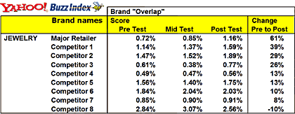
This Major Retailer's strict keyword ROI requirements were causing it to lose ground to competitors. They wanted to increase consumer awareness in key product categories by reaching consumers earlier in the funnel to increase online and offline sales.
To test the viability of search as an awareness building vehicle, the Major Retailer maintained top search rankings, an average rank above two, for 20 high volume category keywords over a period of six weeks. Yahoo! Buzz Index Overlap data were analyzed for each of these keywords before, during and after the test period. The test confirmed what research had indicated, and the chart illustrates findings on one particular category keyword, "Jewelry," and the resulting changes in brand affinity. Prior to the test, our Major Retailer lagged behind all but two of its competitors in the strength of affinity between the brand and the category term "Jewelry," but in just six weeks' time, some considerable changes occurred.
While the Major Retailer maintained consistent positioning in the top search rankings for high volume generic keywords in Google and Yahoo!, it completely overtook one of its competitors in brand affinity as shown in pre-test and post-test scores. Our Major Retailer grew its brand affinity with "Jewelry" by more than 60 percent during the brief test -- by far the largest shift uncovered among the competitive set being tracked. The Major Retailer also climbed to sixth place in the ranking of sites receiving visitors for the keyword "Jewelry," surpassing several prominent online and offline jewelers, according to data from Hitwise, a competitive intelligence service. All in all, the Major Retailer was pleased with the increased visibility, market share and sales driven from the generic keywords in this campaign and continues to deploy this strategy within its search marketing mix.
Search may not work this well as a branding vehicle for every advertiser. Many variables can impact these results, and more research needs to be done showing the relationship between visibility in search results and brand awareness. However, the potential of search to become a cost effective branding tool provides plenty of incentive for advertisers to monitor new research, test frequently and apply new learnings to their search marketing campaigns. Above all else, marketers need to be willing to challenge their assumptions about where search fits into their marketing mix, as it is still growing rapidly as a tool for consumers and advertisers.
Cam Balzer is director of search strategy for Performics, the performance-based marketing division of DoubleClick Digital Advertising Solutions.

