
Special Report: Outsourcers Lose Luster
Though outsourcing is booming, many users say they're less satisfied than they used to be.
By Paul McDougall, InformationWeek
Nov. 22, 2004
URL: http://www.informationweek.com/story/showArticle.jhtml?articleID=53700895
Table Of Contents:
- Special Report: Outsourcers Lose Luster
- Indian Outsourcers Grow Fast, Gain Prominence
- The Rise of Business Process Outsourcing
- Outsourcing Outlook: Exclusive data on the cost of outsourcing
- Try our interactive tool and find out how 12 major outsourcers
fared in customer rankings
- Outsourcing survey methodology
- Buy the Analyzing the Outsourcers Report

Two years ago, Dynegy Inc. appeared destined to follow its larger hometown rival Enron Corp. into scandal and bankruptcy. The Securities and Exchange Commission was suing the Houston energy company for questionable accounting methods, debt was mounting, and the entire energy industry faced punishing scrutiny in the wake of Enron's blowup. Dynegy, with 2003 revenue of $5.8 billion, has since resolved most of its legal troubles, and it has cut debt by about two-thirds.
Dynegy's decision last year to outsource the bulk of its IT operations to Accenture is a big contributor to the turnaround, says Steve Moffitt, Dynegy's CIO and a senior VP. "We were stuck with a technology infrastructure built to support a $40 billion company, and that's not where Dynegy was anymore," he says. Accenture has taken over systems management, help desk, application development, and most of Dynegy's other major IT operations. The result: The company has cut its IT costs by up to 30%. What's more, by outsourcing, Dynegy is better positioned to integrate operations from a recent $1 billion acquisition of Exelon Corp.'s power-generation plants. "We're shifting to a global model, and Accenture has the means to support that," Moffitt says.
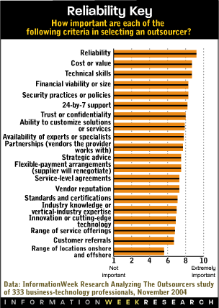
Dynegy's experience indicates why the outsourcing business continues to enjoy steady growth. Worldwide spending on IT services increased 6.4% in 2003 to $570 billion, according to research firm Gartner. Despite that growth, IT executives aren't overly satisfied with their outsourcing partners. A recent InformationWeek Research survey of more than 300 business-technology professionals shows an average customer satisfaction rating of 6.4 on a scale of 1 to 10, where 1 is "not at all satisfied" and 10 is "extremely satisfied." That's down from 7.1 in InformationWeek's last survey of outsourcing buyers two years ago. And nearly 30% say their outsourcer hasn't met their expectations. The survey also asked respondents what they seek in outsourcing providers, rating them in 10 categories, including reliability, reputation, cost/value, and vertical-industry knowledge. (Find out more about the survey methodology)
No. 1 outsourcer Deloitte Consulting, which scored 7.4, was the only provider to score above 7 in the satisfaction ranking. Deloitte also ranked No. 1 in nine out of the 10 categories. That's partly because some of the expertise and best practices housed in the auditing side spills over to its outsourcing business, says IDC analyst Alexander Motsenigos. The firm insists it doesn't pursue outsourcing engagements with its audit clients. Still, Deloitte's connection to a big auditing firm is "a differentiator that others in the market don't have," Motsenigos says.
Deloitte also is the only outsourcer in the group that isn't publicly traded, and it attributes part of its success to the fact that it answers to customers, not Wall Street. "Outstanding," is how one customer describes Deloitte's reliability and responsiveness. The customer, an IT manager at a West Coast test-and-measurement equipment manufacturer, says Deloitte hit the mark with a recent Siebel Systems Inc. implementation.
Outsourcing pays off for Deloitte. Its revenue from systems integration, application outsourcing, and consulting increased 5% from 2002 to 2003 and now stands at $5 billion a year, Motsenigos estimates.
Accenture and Capgemini tied for second in our ranking, with overall scores of 6.8. Accenture's flexibility is a strong trait, Dynegy's Moffitt says. Under the deal, the energy company owns its servers and software, and its employees have direct contact with Dynegy's internal IT staff when problems arise. "We wanted to maintain a lot of control internally, and they supported that," Moffitt says.
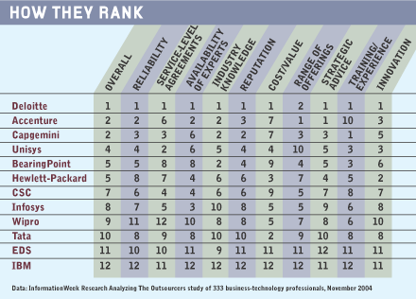
In last and next to last place, respectively, are two of the industry's most dominant players, IBM Global Services and EDS. Respondents gave IBM a mediocre 5.3 out of 10 for reliability, and IBM and EDS landed at the low mark of 5.4 for innovation.
IBM doesn't pay enough attention to its smaller contracts, says Brian Clement, delivery manager for human-resources and payroll-services firm Ceridian Canada. "They were being a bit lackadaisical and taking our business for granted," he adds. Ceridian has a multimillion-dollar contract with IBM to host its PowerPay payroll-management application from its data center in Toronto. The mission-critical application crashed in June. "They made a mistake which actually brought the app down," Clement says. It was IBM's vaunted image as a blue-chip service provider that initially steered Ceridian toward the vendor. "We wanted to put that brand on it--outsourced by IBM," he says. Nevertheless, Ceridian Canada just renewed its contract with IBM; Clement wants to fix the relationship rather than ditch the vendor. Repairing the situation should be less of a hassle than engaging a new outsourcer, he says. IBM declined to comment.
EDS's poor showing illustrates that the onetime powerhouse may have to work harder and faster at making the organizational and management changes demanded by CEO Michael Jordan, and delivering on its new IT road map to provide customers with a utility computing and mainframe migration strategy, even as it continues to try to solve some challenging financial issues. (For more about EDS's turnaround plans, see "In Search Of Agility," Oct. 4, p. 34.) The company last week settled a dispute with outside auditors and reported a third-quarter loss of $153 million from the write-down of assets related to a large contract to build a Navy intranet.
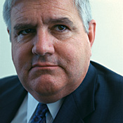
While Nextel has been satisfied with EDS's service levels, there are concerns about its fiscal problems, CIO LeFave says.
Photograph by David Deal
Some customers who say they're satisfied with EDS's service levels remain concerned about the continuing fiscal problems in Plano, Texas. "We're not immune to the allegations and issues they have to deal with," says Dick LeFave, CIO of Nextel Communications Inc. LeFave is committed to spending more than $100 million with EDS over the next two years. He's not alone in wanting a partner that's on strong financial ground. Respondents to our survey assigned the financial viability of a vendor a score of 8.3 out of 10 in terms of importance in their selection process. However, LeFave sees improvements under Jordan. "They bring us a solid, reliable operating environment," he says.
Another prominent vendor, Hewlett-Packard, turned in a good performance, but its fifth-place tie with BearingPoint is a comedown from its first-place ranking two years ago. HP's professional-services revenue grew 13% year over year in the fourth quarter. The growth isn't coming at the expense of customer service, insists Joe Hogan, marketing VP for HP's outsourcing group. "You don't grow unless you have a high level of customer satisfaction," he says.
Some technology chiefs, however, seem antsy with their outsourcing partners. Larry Bonfante, CIO at the U.S. Tennis Association, has his ax out. In 2002, the group outsourced most of its IT work to Affiliated Computer Services Inc. (Affiliated didn't garner the 25 user responses required to qualify for a place in our survey.) The national governing body for tennis had hoped to access more efficient, capable IT workers through its application and infrastructure outsourcing deal with ACS. It didn't. Bonfante found ACS's process controls wanting and complains that the staffers assigned to his account lacked flexibility. That's a big problem for the association, which has an internal IT staff of eight, but its 675,000 members depend on its Web-based TennisLink application for everything from scheduling tournaments to managing league play.

The U.S. Tennis Association will split IT outsourcing into two parts, Bonfante says.
Photograph by Erika Larsen/Redux Pictures
Next year, Bonfante will split his IT outsourcing purchase into two contracts: one for application outsourcing and one for infrastructure management. "The different providers have strengths and weaknesses; asking one to do it all may be a bit too much," he says. ACS may get a sniff only at the application contract, an area where Bonfante says the company "did a credible job."
It may be no coincidence that there's something of an inverse relationship between a service provider's market share and customer satisfaction. ACS is the fifth-largest U.S. outsourcer by revenue; IBM and EDS rank first and second. They simply may be getting too big. "Meeting service levels becomes a challenge as you get bigger," says Atul Vashistha, CEO of outsourcing advisory firm neoIT. Part of the problem for the big vendors is finding enough qualified staffers to meet service obligations, Vashistha says.
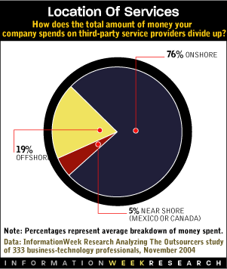
That has some buyers looking at smaller, more specialized vendors. To develop apps, Bonfante says the tennis association may turn to Keane Inc., a service provider with about a third the revenue of EDS, which focuses on application development and management.
A number of CIOs have begun to look for help outside the country. About a quarter of IT services spending among survey respondents went offshore to low-cost locations such as India, or near shore to Canada and Mexico. Some outsourcing business went to far-flung operations of U.S. companies. Accenture, for instance, provides Dynegy with application-development services in India. Moffitt likes the cost savings, but he concedes that the time and cultural differences present management challenges. "It does increase complexity," he says.
Offshore providers hardly represent a panacea. The three Indian companies in our survey--Infosys Technologies, Tata Consultancy Services, and Wipro Technologies--all ranked in the lower half of the results. Offshore service providers are generally perceived as offering the best price because they can draw upon an inexpensive labor pool, but only Tata received a notably high score (7.0) for value. (For more about offshore-outsourcing providers, see story, "Indian Outsourcers Grow Fast, Gain Prominence".) Our survey addresses one piece of conventional wisdom that's commonly misperceived: Outsourcing isn't always done at the expense of IT jobs. Nearly a third of the organizations surveyed increased IT jobs in the past year, even though they outsourced some work. Many businesses farm out technology work because their own staffs are working at full capacity. Ceridian Canada hasn't reduced its IT head count since striking its deal with IBM. Rather, the company turned to the service provider as a means to launch quickly a new project with skills it lacked in-house. "We wanted to get to market quickly because we knew a competitor was coming out with something similar," Clement says.
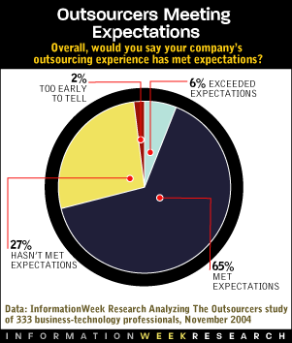
By far the largest number of survey respondents, 47%, pointed to operational expertise as one of the most important reasons to partner with an outsourcer. More people cited expertise over cost savings (35%), which could reflect a general upswing in the economy. In 2002, cost savings was the reason respondents most frequently cited for outsourcing. The shift means businesses may be thinking more strategically about IT. The main reason health insurer Blue Cross Blue Shield of Massachusetts signed on for a multiyear, $320 million extension to its contract with EDS was "to help move our business forward," CIO Carl Ascenzo says. To be sure, Ascenzo wants EDS to help him keep his IT costs in check, but he wants access to applications such as EDS's MetaVance, which lets Blue Cross Blue Shield members tailor their own interactions with the insurer.
That a good outsourcing partner can deliver revenue-generating business enhancements, and not just cost savings, may partly explain why outsourcing spending is rising. In 2002, 51% of businesses InformationWeek surveyed spent $1 million or more on outsourcing, and only 20% allotted more than $10 million. Now, nearly 60% earmark $1 million or more, and 25% spend more than $10 million.
Increased spending on outsourcing means an increased focus on the minutia of the deal. Nearly half of our respondents get outside help when constructing outsourcing deals. Such deals are more complex as businesses turn over a greater portion of their operations to third parties. "The issues can range from whether there is a legal transfer of intellectual property to who is responsible for the pensions of employees that get moved to the outsourcer," says lawyer William Bierce of law firm Bierce & Kenerson. At Ceridian Canada, in-house counsel helps to construct tighter contracts with IBM to avoid future problems. "We are moving from service-level objectives to service-level agreements," Clement says.
Outsourcers face tough challenges to satisfy their clients as companies rely more on their services. And, as our survey suggests, there's plenty of room for improvement.
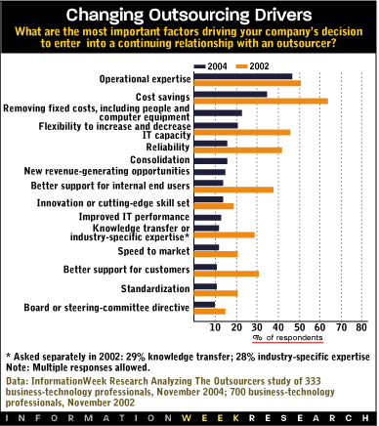
Outsourcing Survey Methodology
InformationWeek Research's Analyzing The Outsourcers is part of an annual series of reader research studies. The studies are based on surveys of more than 300 business-technology professionals via telephone and Internet. Respondents were given a list of 18 major vendors but also offered a chance to write in other vendors they work with. To be included in the study, a vendor had to have received a minimum of 25 evaluations. For the purposes of the study, "outsourcing" was defined as a continuing contractual relationship with a third party for the maintenance and management of a major IT or business-process function. Short-term engagements weren't included. Nearly 40% of the evaluators work in companies with more than $1 billion in annual revenue.

Indian Outsourcers Grow Fast, Gain Prominence

By Paul McDougall, InformationWeek
Nov. 22, 2004
URL: http://www.informationweek.com/story/showArticle.jhtml?articleID=53701018
Table Of Contents:
- Special Report: Outsourcers Lose Luster
- Indian Outsourcers Grow Fast, Gain Prominence
- The Rise of Business Process Outsourcing
- Outsourcing Outlook: Exclusive data on the cost of outsourcing
- Try our interactive tool and find out how 12 major outsourcers
fared in customer rankings
- Outsourcing survey methodology
- Buy the Analyzing the Outsourcers Report

For the first time, offshore providers garnered enough responses to be included in InformationWeek Research's Analyzing The Outsourcers study. While the companies--Infosys Technologies, Tata Consultancy Services, and Wipro Technologies--didn't score particularly high in the overall rankings, their very appearance shows the shifting landscape of the IT-services market.
Most of the Indian firms have been providing a range of offshore services for years. However, they've shown stunning growth in recent quarters. Infosys, Tata, and Wipro are expected to, on average, see revenue growth of 36% this year, according to company projections, while expansion in the IT-outsourcing market as a whole is expected to be in the single digits. And overall, worldwide spending on offshore IT services will grow to $17 billion in 2008 from $7 billion in 2003, a compound annual growth rate of almost 20%, according to IDC.
So what drives buyers of IT services to employ Indian labor? It's more than price. All three offshore firms scored well in terms of domain expertise and range of offerings, an indication that Indian service providers are outgrowing their reputation as body shops that specialize in commodity work. A number of offshore players are winning more infrastructure-management contracts.
That's leading a number of Indian service providers to increase their presence in the United States. Wipro has more than 3,000 employees in the United States and Canada and maintains offices in almost every large North American city. Other major Indian firms are following suit.
A Wipro survey this year of 145 technology executives worldwide showed that 30% planned to offshore their companies' IT infrastructure over the next year. Our survey shows that location was the least important factor driving the selection of a service provider--technology executives are more concerned with a vendor's reliability, value proposition, and technical skills.
Next year, a new market entrant could pull even more business offshore. General Electric Capital International Services, based in India, is being spun off from parent company GE and plans to compete aggressively for IT and business-process-outsourcing contracts outside of GE. With more than 12,000 employees and plans to expand into South America and Eastern Europe, expect the GE spin-off to show up on future reports. Says Stan Lepeak, outsourcing analyst at Meta Group: "They will be a significant player in the market."

The Rise Of Business-Process Outsourcing
More than one of four respondents to <I>InformationWeek</I> Research's Analyzing The Outsourcers survey say they have outsourced at least one business process to a third party.
By Paul McDougall, InformationWeek
Nov. 22, 2004
URL: http://www.informationweek.com/story/showArticle.jhtml?articleID=53700078
Table Of Contents:
- Special Report: Outsourcers Lose Luster
- Indian Outsourcers Grow Fast, Gain Prominence
- The Rise of Business Process Outsourcing
- Outsourcing Outlook: Exclusive data on the cost of outsourcing
- Try our interactive tool and find out how 12 major outsourcers
fared in customer rankings
- Outsourcing survey methodology
- Buy the Analyzing the Outsourcers Report

As businesses become more comfortable with outsourcing IT work, many take the next step and hand over entire business processes, such as human-resources administration or transaction processing, to IT outsourcing companies. More than one of four respondents to InformationWeek Research's Analyzing The Outsourcers survey, which will be published in the Nov. 22 issue, say they have outsourced at least one business process to a third party.
In response to the demand, many classic IT outsourcing vendors are boosting their business-process outsourcing offerings--but with a twist. To compete with pure-play business-process outsourcers such as payroll processor Automatic Data Processing Inc. or HR outsourcing company Hewitt Associates, IT outsourcers meld IT outsourcing and BPO. That is, they will provide customers with the infrastructure and the business applications and will staff the business-process function. EDS, for instance, is building a platform of hardware, middleware, and business applications called agile infrastructure, on top of which it wants to provide business services such as HR management. "We're gearing up to go into some of these more horizontal areas," EDS CEO Michael Jordan said in a recent interview. EDS is also pushing into other areas such as procurement and finance and accounting.
In doing so, EDS will run into stiff competition as other vendors eying similar services. Hewlett-Packard recently launched its own finance and accounting service and scored big when, last March, it landed Procter & Gamble as its first customer under a multiyear deal. "We're taking a strong internal capability and offering it to the market," HP executive VP Ann Livermore said at the time. IBM is also beefing up its BPO capabilities and adding an offshore component. Earlier this year, it acquired India-based Daksh E-Services for what analysts estimate was a price between $150 million and $200 million. Daksh operates a number of call centers in India and serves customers that include Sprint and Amazon.
Such moves indicate that IT vendors are building out their day-to-day operational capabilities in an effort to play in the fast-growing BPO market, says Forrester Research analyst John McCarthy. IBM used to subcontract much of the lower-level call-center work in its customer engagements but now seeks to capture that revenue, he says. There is significant revenue to be had. According to Gartner, the worldwide BPO market will grow 8% in 2004 to $131 billion.

Cost No Longer Prime Motivator To Outsource
One-third of surveyed business-tech managers cite cost savings as main reason to outsource; two years ago, two-thirds gave that response
By Eric Chabrow, InformationWeek
Nov. 22, 2004
URL: http://www.informationweek.com/story/showArticle.jhtml?articleID=52601338
Table Of Contents:
- Special Report: Outsourcers Lose Luster
- Indian Outsourcers Grow Fast, Gain Prominence
- The Rise of Business Process Outsourcing
- Outsourcing Outlook: Exclusive data on the cost of outsourcing
- Try our interactive tool and find out how 12 major outsourcers
fared in customer rankings
- Outsourcing survey methodology
- Buy the Analyzing the Outsourcers Report

More than a third of business-technology professionals surveyed by InformationWeek research say their companies will spend $5 million a year or more on IT outsourcing. On Nov. 22, InformationWeek magazine will publish a package of stories entitled Analyzing The Outsourcers, based on a survey of more than 300 business-technology pros who've assessed the performance of the top dozen IT outsourcing firms. Two years ago, when we last surveyed business-technology executives on this topic, nearly two-thirds cited cost savings as a primary reason to outsource. Now only about a third mention cost savings a main factor to hire outsiders to perform IT work. The most common reason given, cited by nearly half the respondents: operational expertise.
