The online ad attack
Apr 28th 2005
From The Economist print edition

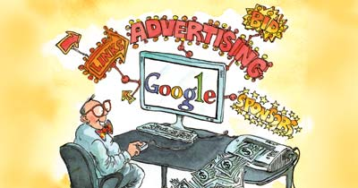
Google's new advertising service could make the internet an even more valuable marketing medium
THIS year the combined advertising revenues of Google and Yahoo! will rival the combined prime-time ad revenues of America's three big television networks, ABC, CBS and NBC, predicts Advertising Age. It will, says the trade magazine, represent a “watershed moment” in the evolution of the internet as an advertising medium. A 30-second prime-time TV ad was once considered the most effective form of advertising. But that was before the internet got going. This week, online advertising made another leap forward.
This latest innovation comes from Google, which has begun testing a new auction-based service for the more sophisticated advertising of brands, rather than of just individual products. Both Google and Yahoo! make most of their money from advertising. Auctioning keyword search-terms, which deliver, along with their own search results, sponsored links to advertisers' websites, has proved to be very lucrative. Advertisers like these links because, unlike with TV ads, they pay only for directly measurable results. They are charged when someone clicks through to their own website.
Both Google and Yahoo!, along with search-site rivals such as Microsoft's MSN and Ask Jeeves (recently bought by Barry Diller's InterActiveCorp), are developing much broader ranges of marketing services. Google, for instance, already provides a service called AdSense. This works rather like an advertising agency, automatically placing sponsored links and other ads on third-party websites. Google then splits the revenue with the owners of those websites, who can range from multinationals to individuals publishing blogs, as online journals are known.
Google's new service extends AdSense in three ways. Instead of Google's software analysing third-party websites to determine from their content what relevant ads to place on them, advertisers will instead be able to select the specific sites where they want their ads to appear. This provides both more flexibility and more precision, says Patrick Keane, Google's head of sales strategy. Firms trying to raise awareness of a brand often want a high level of control over where their ads appear.
The second change involves pricing. Potential advertisers must bid for their ad to appear on a “cost-per-thousand” (known as CPM) basis. This is similar to TV commercials, where advertisers pay according to the number of people who are supposed to see the ad. But the Google system delivers a twist: CPM bids will also have to compete against rival bids for the same ad space from those wanting to pay on a “cost-per-click” basis, the way search terms are presently sold. Google already calculates likely CPM values for the ads that it places on other people's websites.
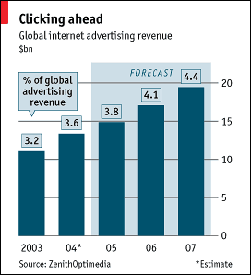

Advertisers promoting a brand sometimes only want to get a name and an image in front of consumers, and not necessarily have them click through to a website. Moreover, click-through marketing tends to be aimed at people who already know they want to buy something and are searching for product and price information. Brand, or “display”, advertising is more often used to persuade people to buy things in the first instance.
The third change is that Google will now offer animated ads—but nothing too flashy or annoying, insists Mr Keane. Google has long been extremely conservative about the use of advertising; it still plans to use only small, text-based ads on its own search sites. But many of its AdSense partners might well be tempted by the prospect of earning a share of revenue for display and animated ads too, especially as such ads are likely to be more appealing to some of the big-brand advertisers.
With the spread of broadband providing faster connections, so called “rich-media” ads, which can contain animation, video and sound, are already becoming more widespread. And these are just the sort of ads favoured by companies trying to build their brands.
This could fuel online ad growth even further. As overall advertising spending continues to recover from the slump that began in 2001 after the bursting of the technology bubble, the internet has become the fastest growing advertising medium. Worldwide ad revenue on the internet grew by 21% in 2004 to $13.4 billion, and it is expected to continue at that pace for the next few years, says ZenithOptimedia, a research firm (see chart). Google and Yahoo!, the two most widely visited sites, are reaping many of the rewards. Google recently announced a net profit of $369m in its first quarter from revenue that soared to $1.3 billion, up 93% compared with the same period a year earlier. Yahoo!'s first-quarter net profits more than doubled to $205m on revenue of $1.2 billion, up 55% from a year earlier.
Terry Semel, Yahoo!'s boss, believes there is a lot more growth to come as firms become even more familiar with online advertising. He happily points out that many big firms still allocate only 2-4% of their marketing budgets to the internet, although it represents about 15% of consumers' media consumption—and is growing. Many young people already spend more time online than they do watching TV.
If Google can prove that bidding for display ads works, then its rivals are bound to follow with similar services. This could shake the industry up even more. DoubleClick, an online-marketing specialist which helped pioneer the delivery of simple banner ads to websites, was sold this week in a deal worth more than $1 billion to a private-equity firm, Hellman & Friedman. Even though its prospects recently brightened, DoubleClick put itself up for sale after facing fierce competition.
Other innovations in online marketing are said to be in the pipeline. Local search and its associated advertising opportunities are one huge growth area. Sites such as eBay, the leading online auctioneer, and Craigslist, which hosts local sites, are soaking up large amounts of classified advertising for everything from used cars to job vacancies that once might have gone to newspapers. Yahoo! is expanding rapidly into entertainment, with film and video clips providing another avenue of advertising. This week, Yahoo! appointed another top executive to its media group, fuelling speculation that the website may start to produce its own entertainment content. That should seriously worry TV broadcasters, who are already losing viewers and ad revenue to the internet.

