Google to Go: Web Access
On Gadgets Gets Better
Retooled Sites Are Faster,
Easier to See on Small Devices;
Checking eBay From Your Cell
By JESSICA E. VASCELLARO
Staff Reporter of THE WALL STREET JOURNAL
December 7, 2005; Page D1
The nation's biggest Internet companies have begun a major push to make it easier to access the Web from cellphones, BlackBerrys and other mobile devices.
Time Warner Inc.'s America Online, Google Inc. and Yahoo Inc. are rolling out small-scale versions of their familiar Web sites that are specifically designed to work effectively on mobile screens. EBay.com, Mapquest.com and CNN.com are among those that have also edited and shrunk their sites for viewing on even the tiniest display.
Last week, AOL launched a mobile Web site that allows individuals to search the Web for content from local pizza places to celebrity photos by typing in search terms from a gadget keyboard. The site also includes links to news, sports, entertainment and weather reports.
Yahoo recently introduced a mobile shopping service that allows users to comparison-shop from portable devices. Typing in the name of an item pulls up product, merchant and price information. Last month, Google, drawing on its maps feature, launched Google Local for mobile, a service that allows users to search for local business locations, locate them on a map, and even call the merchant by clicking on a link.
The improved sites are one more response to an increasingly on-demand culture. Business are struggling to adapt as consumers use the Internet to get what they want, whenever they want it, from the latest episode of a television show to a map with directions to a new restaurant.
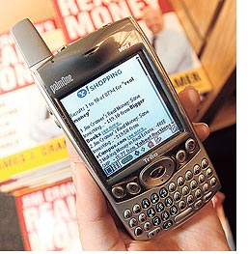
The effort to shrink sites that were initially designed for use at desktop computers with large color monitors is akin to what television studios are doing to make episodes of TV shows such as "Lost" appear crisp and sharp when played on the video iPod.
The wave of development comes as mobile Internet use, considered for years to be sluggish and frustrating, appears to be taking off. The percentage of U.S. wireless subscribers who use their cellphones to browse Internet pages has doubled to 12% since last year, according to NPD Group, a market-research firm in Port Washington, N.Y. And Seattle-based M:Metrics Inc., a market researcher, estimates that more than 24 million U.S. subscribers over the age of 13 accessed the Internet from a mobile device in October.
Most cellphones are wired to access the Internet (95% of new cellphones sold in July, August, and September were Web-enabled, according to NPD Group, up from 81% the year before). To do so, users launch their Internet browsers from an icon on their screens and start browsing by typing a Web address into a search field. Alternatively, they can scroll through a list of menus to access popular sites and services already preloaded on the phone, such as mobile versions of ESPN or the Weather Channel.
But to start browsing, consumers usually have to sign up for a separate data service, of which there are many types. Consumers who want to add Internet browsing to their existing voice plans can buy data plans for $19.99 a month or less depending on the provider. (Plans may run as high as $90 if they include access to corporate email.) For those who expect to do less Web browsing, lower usage plans also are available. Cingular Wireless, for instance, charges $4.99 for one megabyte of data, the equivalent of viewing roughly 100 news headlines.
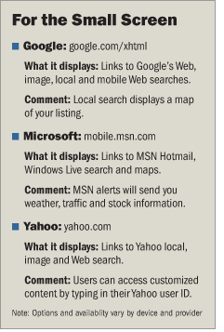
Some users of newer cellphones may find their phones already active for Web browsing. In those cases they'll typically be charged several cents each time they access a site. While some companies charge small subscription fees for premium content that users must download an application to receive, such as customized sports scores, most of the sites and services themselves are free. But they may not be free of advertising for long. Some content providers are looking at ways to use advertising on the miniature Web pages, seeing it as a way to reach targeted audiences. For now, however, most companies are keeping their mobile-optimized sites ad-free while they work on attracting users.
Richard Lichtenstein, a 23-year-old associate consultant at Bain & Co. in New York is an avid user of his Web browser on his T-Mobile BlackBerry. The browser has helped him resolve friendly debates, find the Web site of a band before a concert and locate pictures of movie stars. But at around $40 a month, without voice service, he says if Bain weren't paying for the perks, he probably wouldn't either.
The overall move to Web pages designed for small screens is still in the early stages. In many cases, when you access any Web site from a mobile device, you may see the text and graphics of the normal page awkwardly condensed. But such distorted layouts are becoming less common, as companies take advantage of faster wireless networks and more powerful mobile devices.
Sites tailored for mobile -- the availability of which varies depending on the device and carrier -- typically have only a few links listed on the home page and few or no graphics clogging the screen. The URLs of these sites may be identical to their parent sites or may require adding "mobile" or "wireless" somewhere in the address.
Internet giants Yahoo, Google, MSN and AOL are leading the mobile Web push, but other sites are gaining popularity as well. Among them are mobile versions of ESPN, Mapquest, sites that list movie show times, such as Hollywood.com, and a range of travel sites.
John Ludwig, a founder of Ignition Partners, a venture-capital fund in Seattle, says when his favorite sports teams are playing, he will check scores on his BlackBerry using ESPN around 40 times during each game. While a fan of the mobile Internet, Mr. Ludwig, 45 years old, doesn't like common hassles associated with it: the slowness of the network and the number of necessary clicks. Waiting for a screen to refresh can take anywhere from three to 10 seconds, a seeming eternity for those used to broadband service.
Marc Karimi, a 22-year-old student at Stanford Graduate School of Business in Stanford, Calif., says accessing Web content on a cellphone isn't worth the time. After he bought a new Audiovox cellphone, he went on a browsing frenzy using the little keys to check things like movie times, directions and restaurant phone numbers. The data costs only came to an additional $5 on his $65 cell phone bill. But after two months of heavy use, he says he was bothered by the slow speeds and now keeps it only in case of an emergency.
But problems such as Mr. Karimi's may slowly start to disappear. Content and service providers say they expect service speeds to improve as wireless networks get faster. And some are already taking steps to reduce browsing time.
Last month Cingular Wireless, a joint venture of San Antonio-based SBC Communications Inc. and BellSouth Corp. of Atlanta, revamped its Internet service to cut the average time it takes to look up a listing on the Web by more than half, a company representative says.
Designed-for-mobile advertising, perhaps a tiny banner ad that appears on the top of a screen, could take off within the next year, predicts Heidi Lehmann, chairman of the advertising standards committee of the Mobile Marketing Association, a Boulder, Colo., trade association.
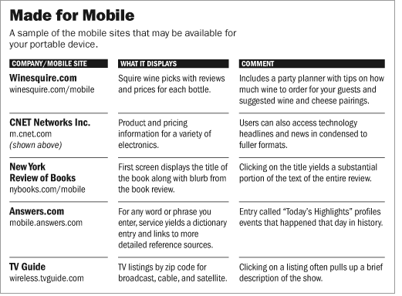
Write to Jessica E. Vascellaro at jessica.vascellaro@wsj.com¹
URL for this article:
http://online.wsj.com/article/SB113392267580515883.html
Hyperlinks in this Article:
(1) mailto:jessica.vascellaro@wsj.com

Copyright 2005 Dow Jones & Company, Inc. All Rights Reserved

